Deploying a Swiggy clone app using Kubernetes.

Let's use Terraform to create an EC2 instance for Jenkins, Docker, and SonarQube.
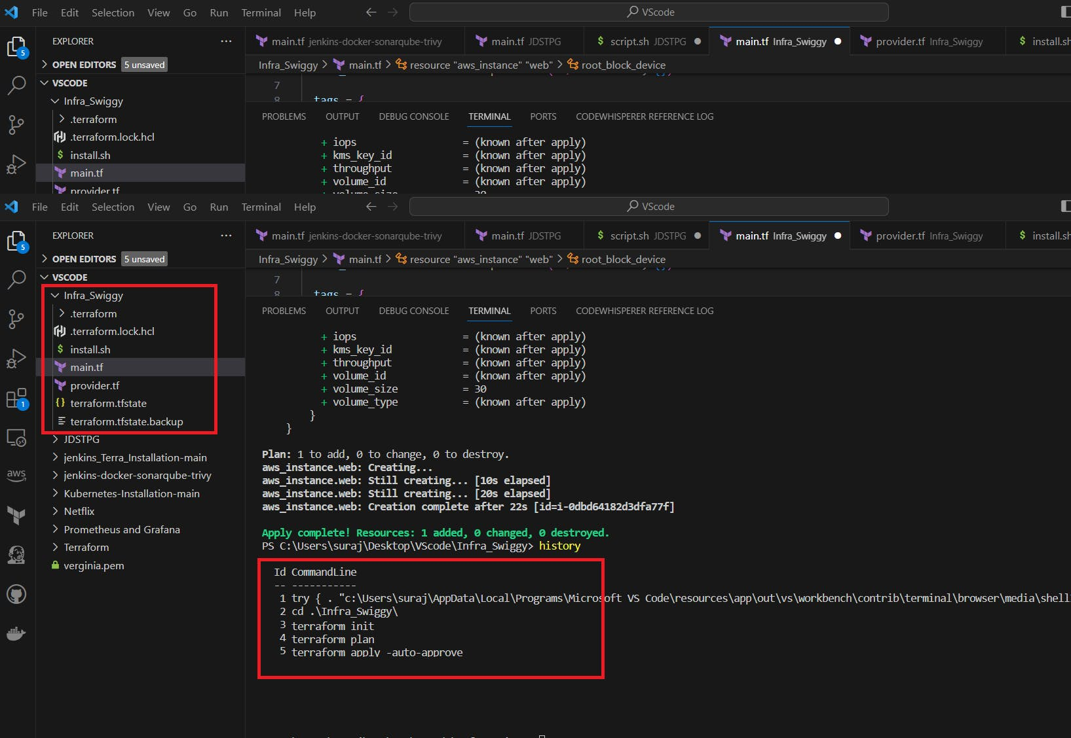
main.tf :
resource "aws_instance" "web" {
ami = "ami-0287a05f0ef0e9d9a" #change ami id for different region
instance_type = "t2.large"
key_name = "mumbai" #change key name as per your setup
vpc_security_group_ids = [aws_security_group.Jenkins-sg.id]
user_data = templatefile("./install.sh", {})

tags = {
Name = "Jenkins-sonarqube"
}

root_block_device {
volume_size = 30
}
}

resource "aws_security_group" "Jenkins-sg" {
name = "Jenkins-sg"
description = "Allow TLS inbound traffic"

ingress = [
for port in [22, 80, 443, 8080, 9000, 3000] : {
description = "inbound rules"
from_port = port
to_port = port
protocol = "tcp"
cidr_blocks = ["0.0.0.0/0"]
ipv6_cidr_blocks = []
prefix_list_ids = []
security_groups = []
self = false
}
]

egress {
from_port = 0
to_port = 0
protocol = "-1"
cidr_blocks = ["0.0.0.0/0"]
}

tags = {
Name = "jenkins-sg"
}
}
provider.tf
terraform {
required_providers {
aws = {
source = "hashicorp/aws"
version = "~> 5.0"
}
}
}
# Configure the AWS Provider
provider "aws" {
region = "ap-south-1" #change your region
}
install.sh
#!/bin/bash
sudo apt update -y
wget -O - https://packages.adoptium.net/artifactory/api/gpg/key/public | tee /etc/apt/keyrings/adoptium.asc
echo "deb [signed-by=/etc/apt/keyrings/adoptium.asc] https://packages.adoptium.net/artifactory/deb $(awk -F= '/^VERSION_CODENAME/{print$2}' /etc/os-release) main" | tee /etc/apt/sources.list.d/adoptium.list
sudo apt update -y
sudo apt install temurin-17-jdk -y
/usr/bin/java --version
curl -fsSL https://pkg.jenkins.io/debian-stable/jenkins.io-2023.key | sudo tee /usr/share/keyrings/jenkins-keyring.asc > /dev/null
echo deb [signed-by=/usr/share/keyrings/jenkins-keyring.asc] https://pkg.jenkins.io/debian-stable binary/ | sudo tee /etc/apt/sources.list.d/jenkins.list > /dev/null
sudo apt-get update -y
sudo apt-get install jenkins -y
sudo systemctl start jenkins
sudo systemctl status jenkins

#install docker
sudo apt-get update
sudo apt-get install docker.io -y
sudo usermod -aG docker ubuntu
newgrp docker
sudo chmod 777 /var/run/docker.sock
docker run -d --name sonar -p 9000:9000 sonarqube:lts-community

#install trivy
sudo apt-get install wget apt-transport-https gnupg lsb-release -y
wget -qO - https://aquasecurity.github.io/trivy-repo/deb/public.key | gpg --dearmor | sudo tee /usr/share/keyrings/trivy.gpg > /dev/null
echo "deb [signed-by=/usr/share/keyrings/trivy.gpg] https://aquasecurity.github.io/trivy-repo/deb $(lsb_release -sc) main" | sudo tee -a /etc/apt/sources.list.d/trivy.list
sudo apt-get update
sudo apt-get install trivy -y
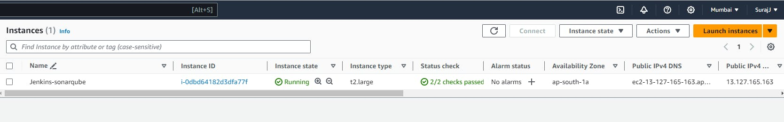
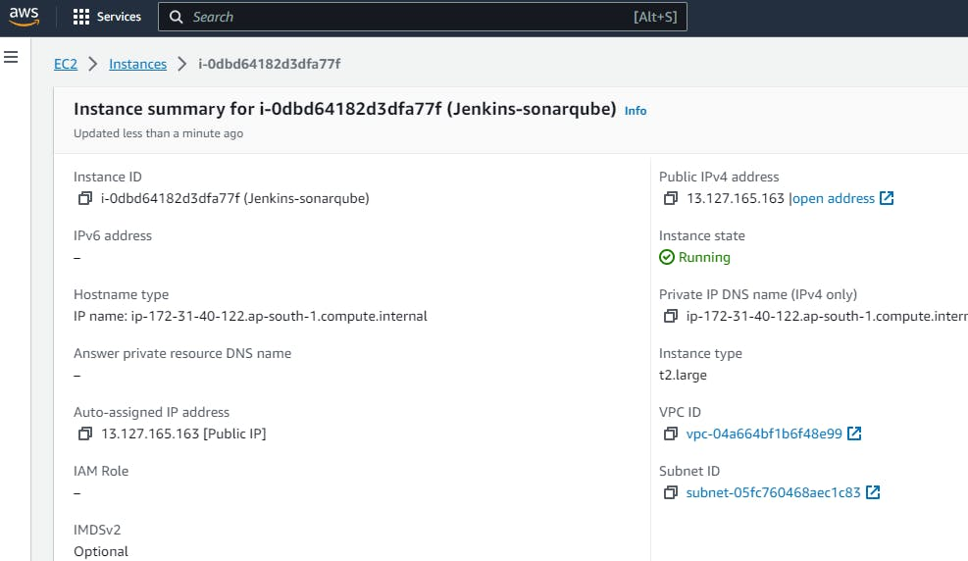
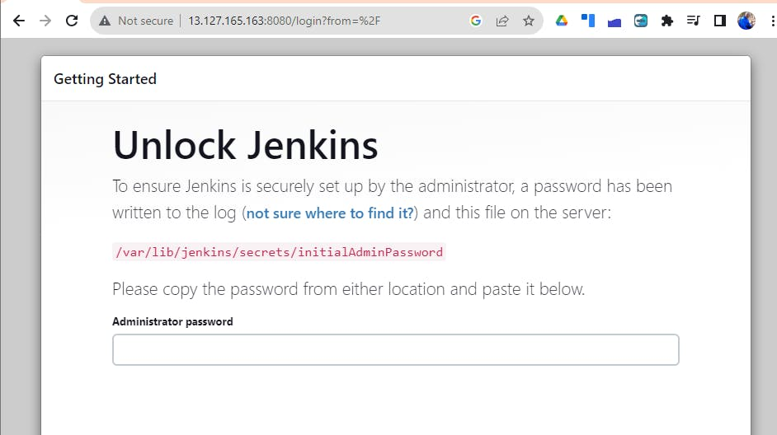
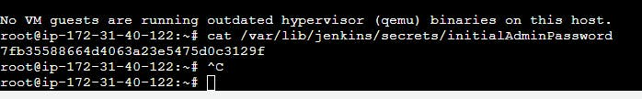
Use > admin >admin
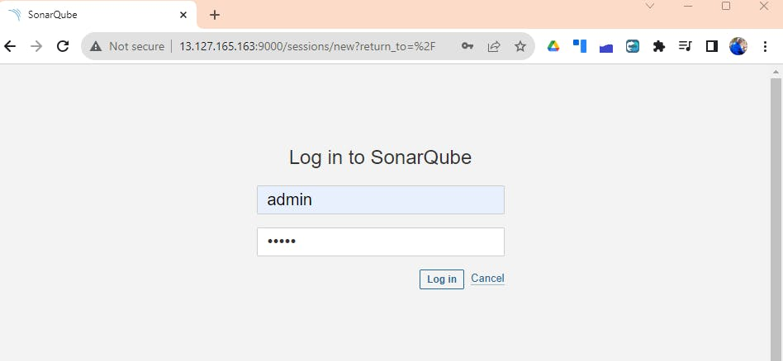
Now Install the Plugins without restarting Jenkins -
Eclipse Temurin installer
Sonarqube Scanner
NodeJs
OWASP Dependency Check
Docker
Docker Commons
Docker Pipeline
Docker API &
Docker-build-step
Install Each plugin like the below:-
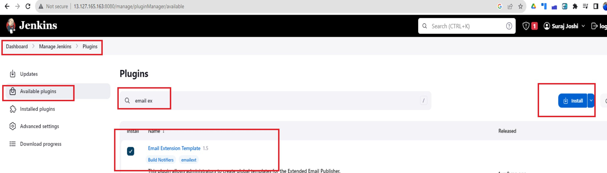
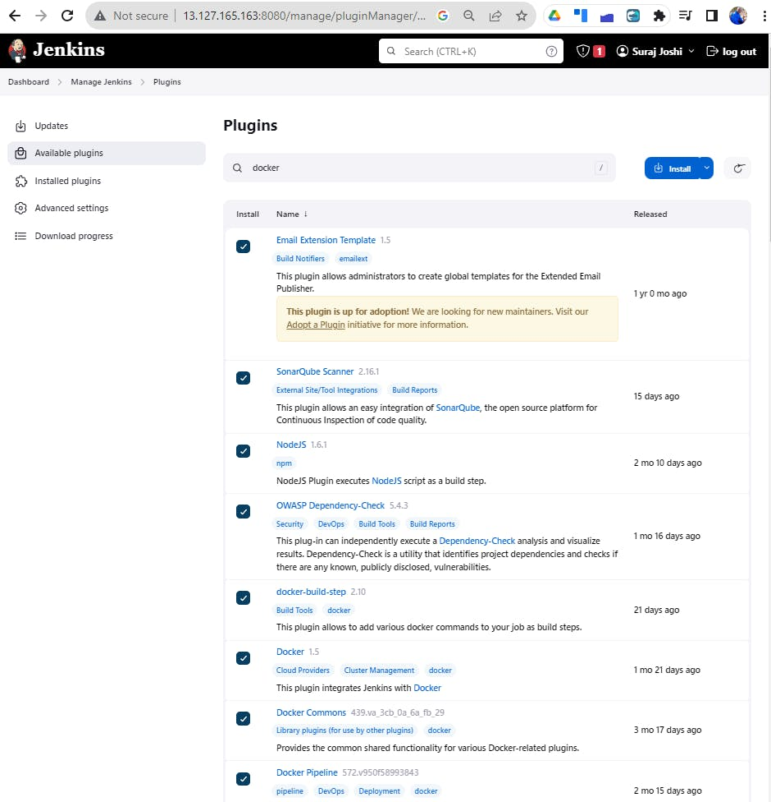

Goto Manage Jenkins → Tools → Install JDK(17) and NodeJs(16)→ Click on Apply and Save
JDK
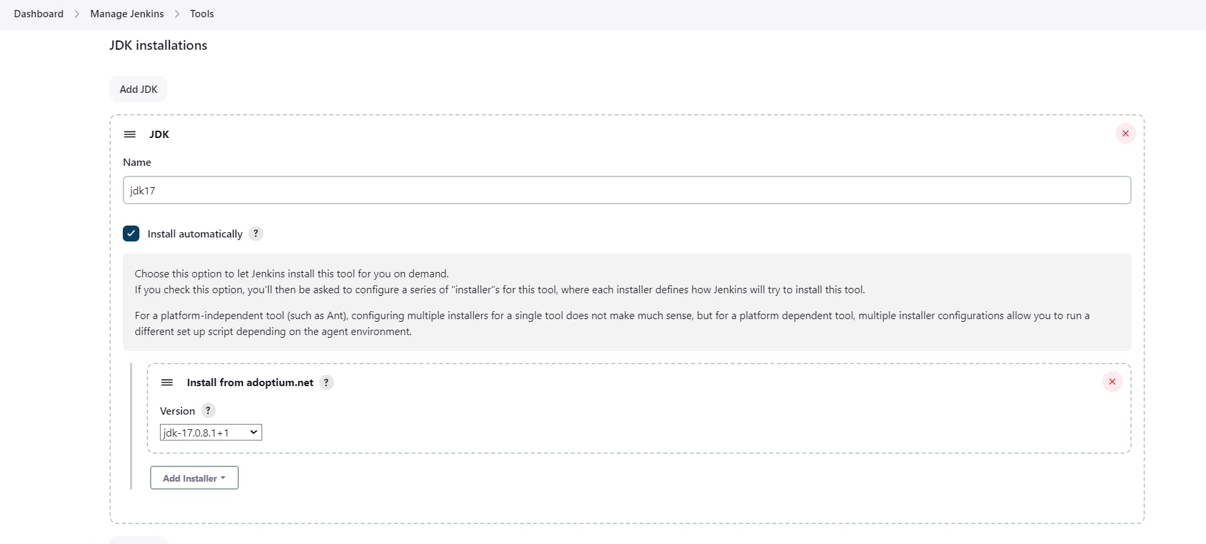

NodeJS
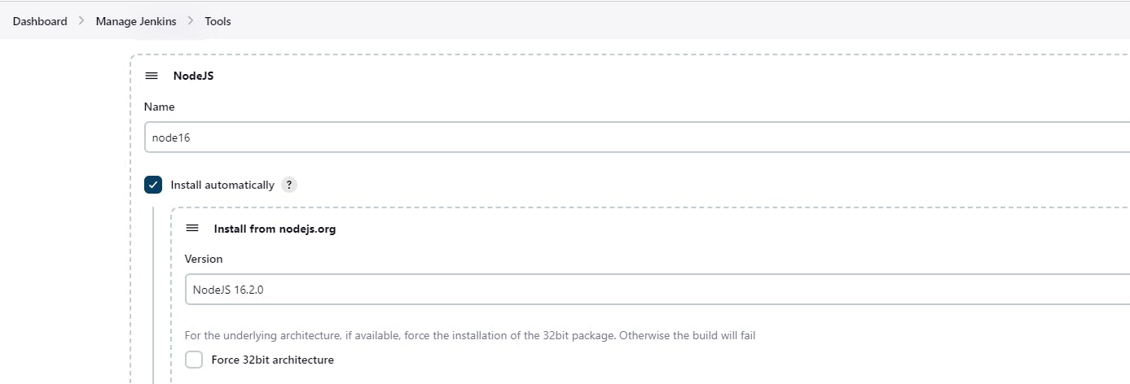
Dependency-Check
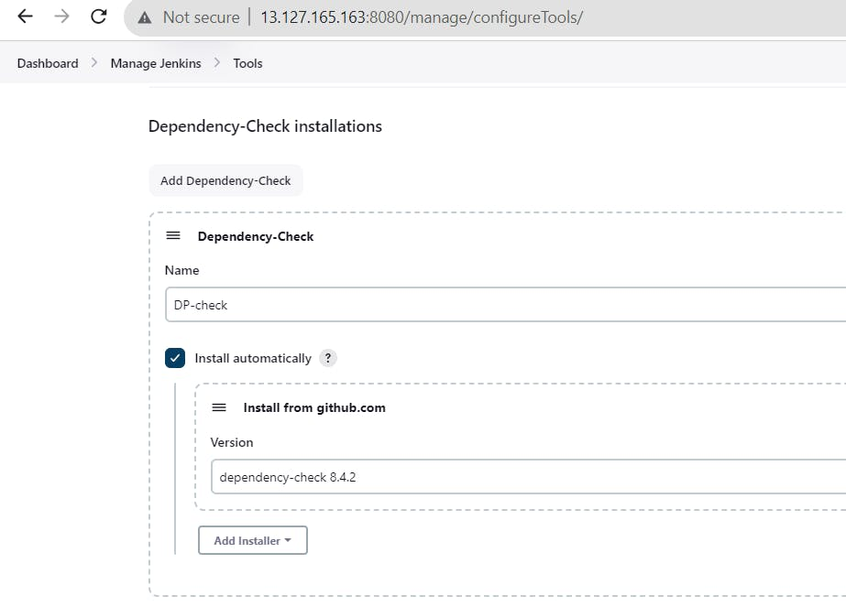

SonarQube Scanner installations :
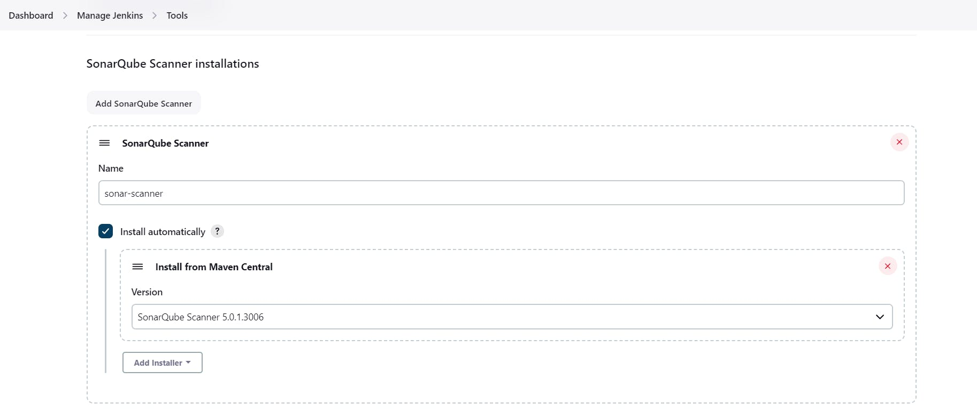
Retrieve the Public IP Address of your EC2 Instance, and access Sonarqube running on Port 9000, please follow these steps:
- Obtain the Public IP Address of your EC2 Instance.
- Using a web browser, go to your Sonarqube Server's Public IP address followed by port 9000 (e.g., <Public IP>:9000).
Use admin --> admin
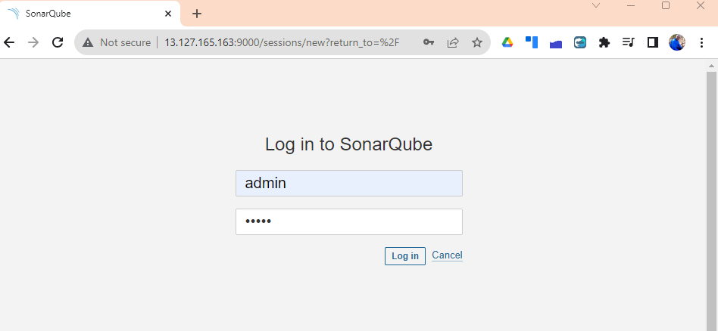
Setup your Password:
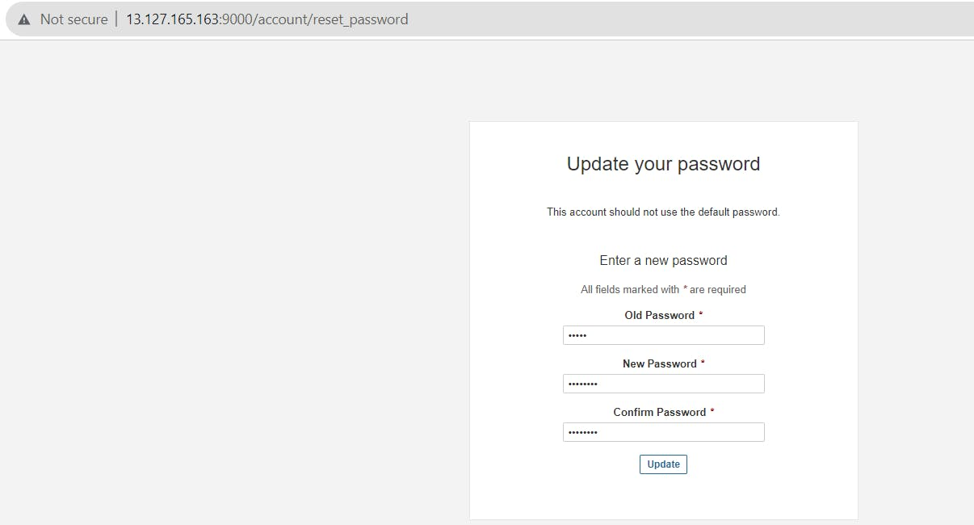
- Navigate to the Sonarqube Administration section.
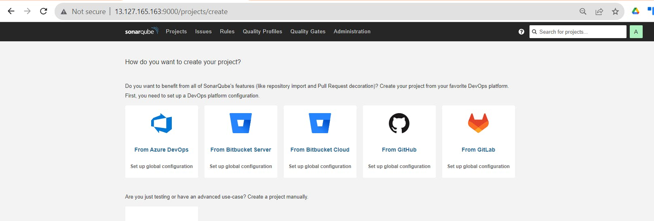
- In the Administration section, locate and click on the "Security" option.
- Within the Security section, find and select "Users."
- Click on the "Tokens" option.
- Provide a name for the token to easily identify its purpose.
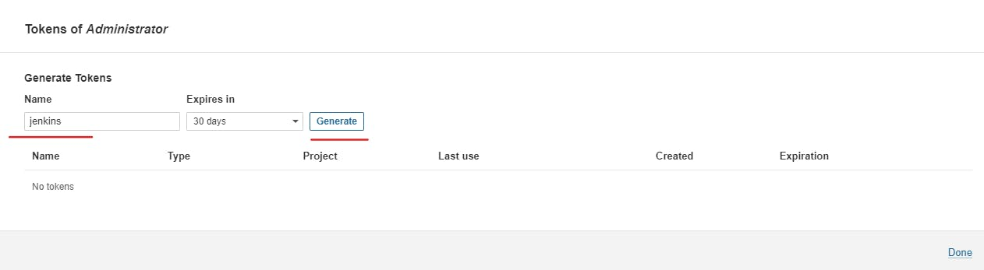
Click on the "Generate Token" button to create the token.
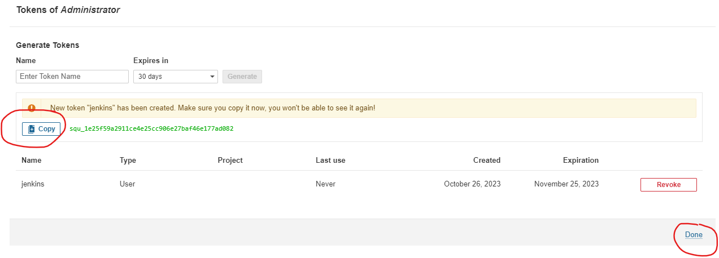
copy this token & keep it with you.
Goto Jenkins Dashboard → Manage Jenkins → Credentials → Add Secret Text. It should look like this
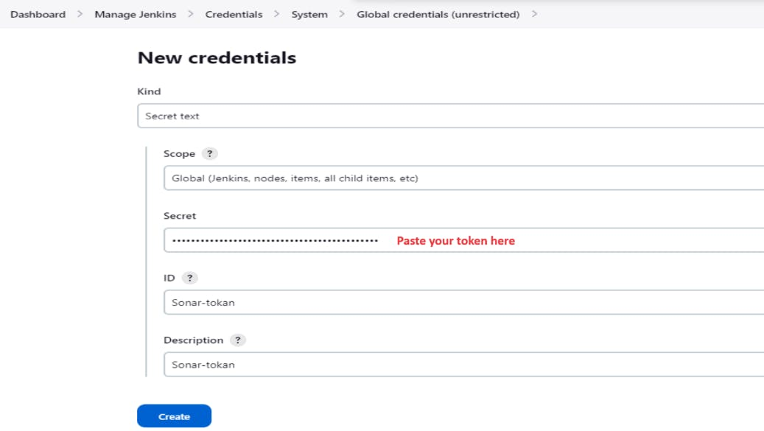
Now, go to Dashboard → Manage Jenkins → System
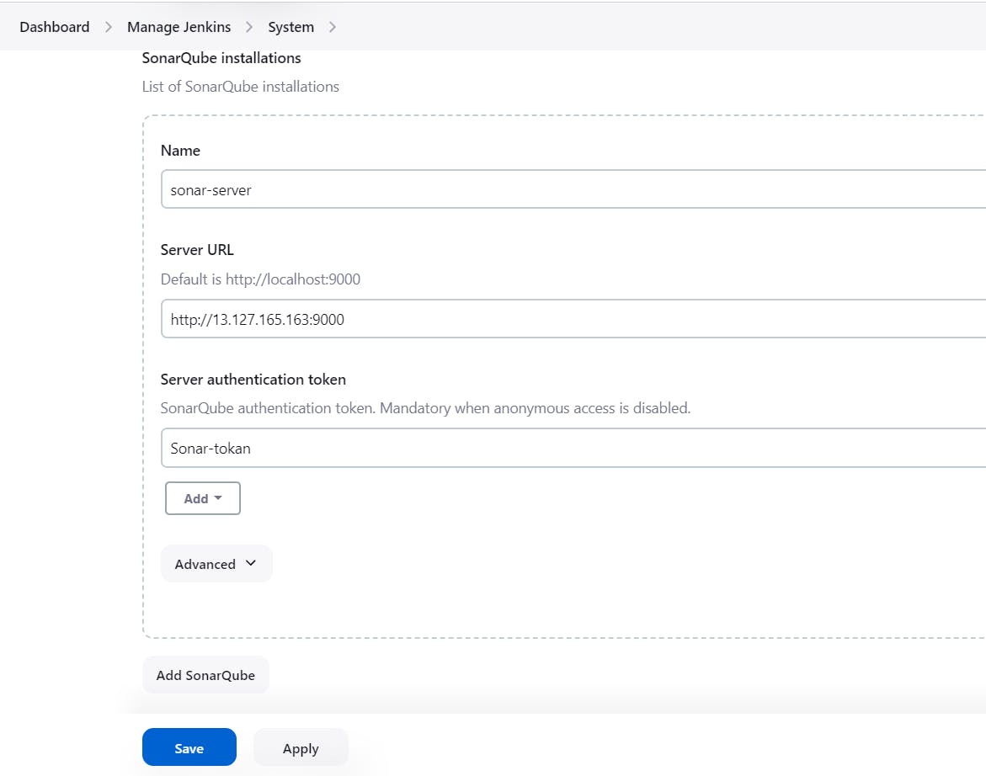
In the Sonarqube Dashboard add a quality gate also
Administration--> Configuration-->Webhooks
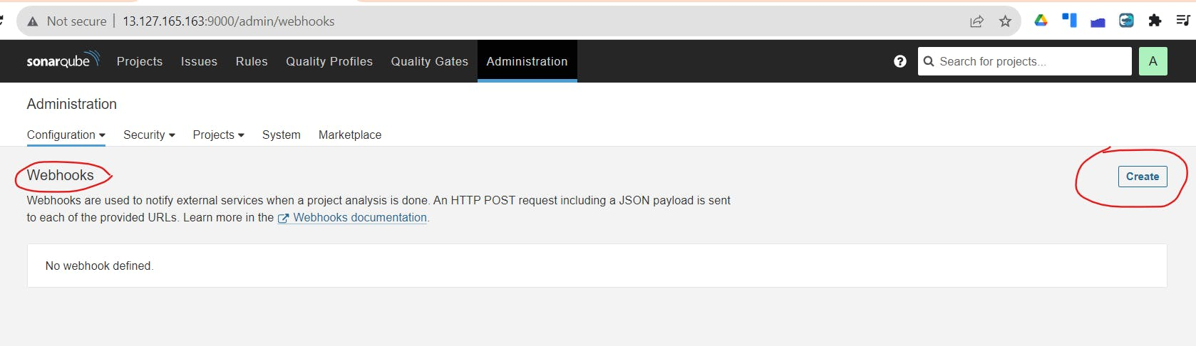
Add details Link below & create
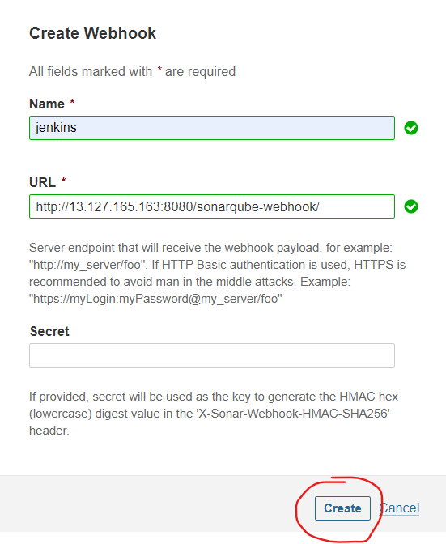
Now Go to Dashboard > New Item
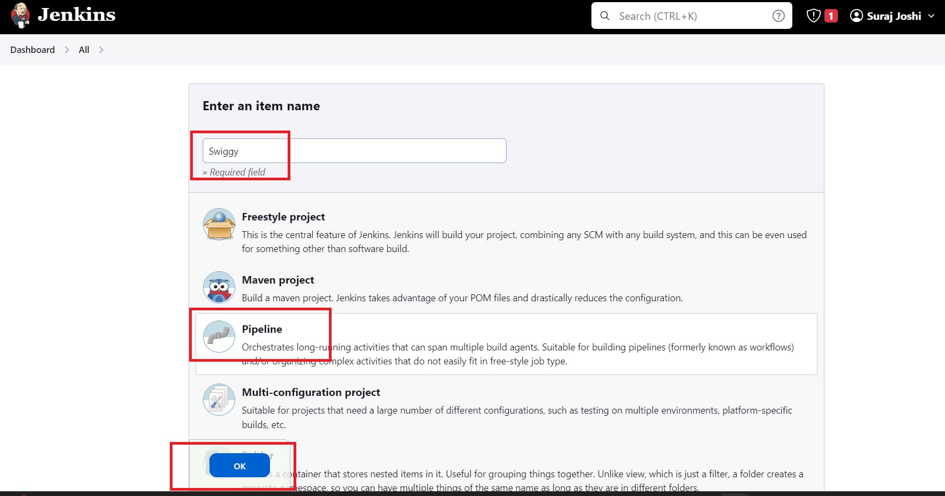
Now, let's navigate to our pipeline configuration and include the script
COPY
COPY
Click on Build now, you will see the stage view like thispipeline{
agent any
tools{
jdk 'jdk17'
nodejs 'node16'
}
environment {
SCANNER_HOME=tool 'sonar-scanner'
}
stages {
stage('clean workspace'){
steps{
cleanWs()
}
}
stage('Checkout from Git'){
steps{
git branch: 'main', url: 'https://github.com/surajpjoshi/Swiggy-clone.git'
}
}
stage("Sonarqube Analysis "){
steps{
withSonarQubeEnv('sonar-server') {
sh ''' $SCANNER_HOME/bin/sonar-scanner -Dsonar.projectName=Swiggy \
-Dsonar.projectKey=Swiggy '''
}
}
}
stage("quality gate"){
steps {
script {
waitForQualityGate abortPipeline: false, credentialsId: 'Sonar-token'
}
}
}
stage('Install Dependencies') {
steps {
sh "npm install"
}
}
stage('OWASP FS SCAN') {
steps {
dependencyCheck additionalArguments: '--scan ./ --disableYarnAudit --disableNodeAudit', odcInstallation: 'DP-Check'
dependencyCheckPublisher pattern: '**/dependency-check-report.xml'
}
}
stage('TRIVY FS SCAN') {
steps {
sh "trivy fs . > trivyfs.txt"
}
}

}
}
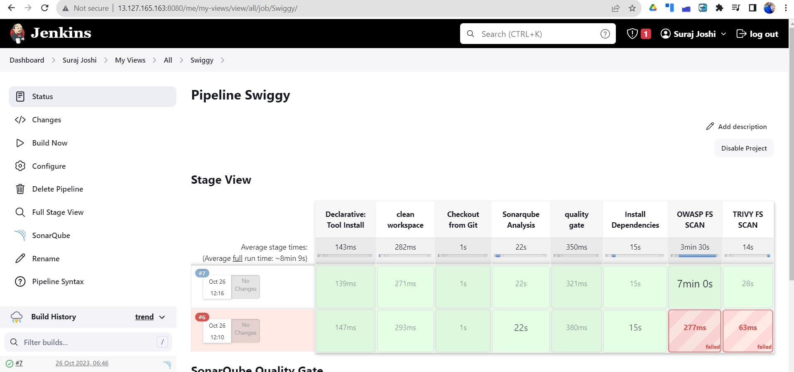
To see the report, you can go to Sonarqube Server and go to Projects.
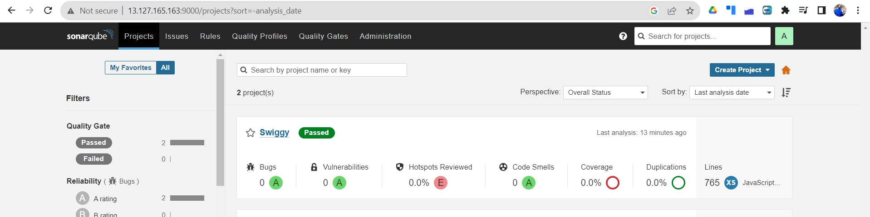

Docker Image Build and Push
COPY
COPY
stage("Docker Build & Push"){
steps{
script{
withDockerRegistry(credentialsId: 'docker', toolName: 'docker'){
sh "docker build -t swiggy ."
sh "docker tag swiggy surajpjoshi/swiggy:latest "
sh "docker push surajpjoshi/swiggy:latest "
}
}
}
}
stage("TRIVY"){
steps{
sh "trivy image surajpjoshi/swiggy:latest > trivyimage.txt"
}
}
Add DockerHub Username and Password under Global Credentials
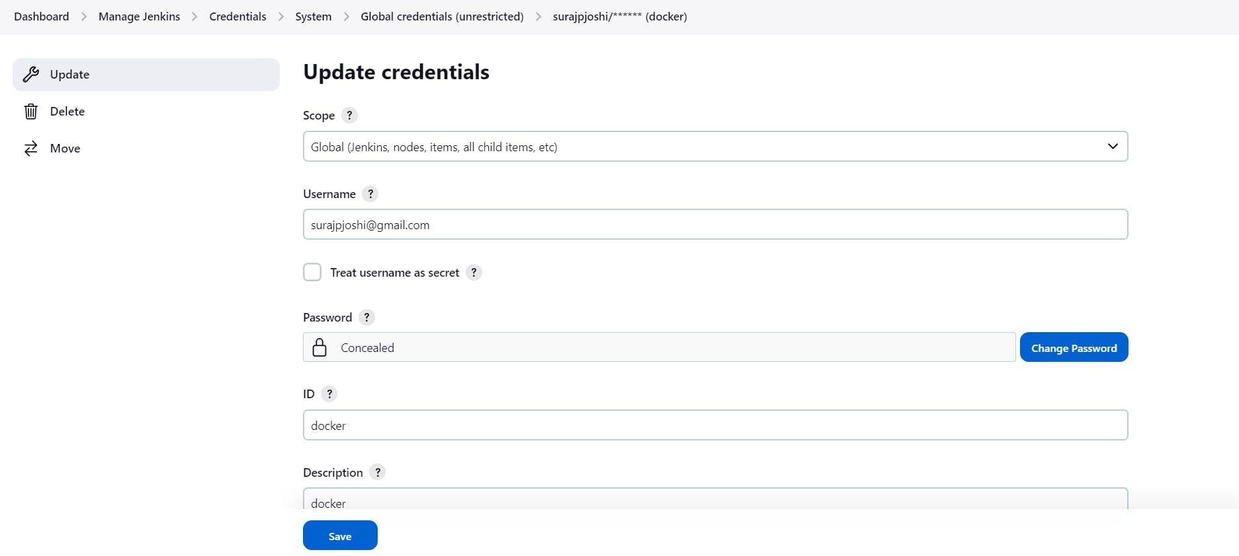
Now, goto Dashboard → Manage Jenkins → Tools →
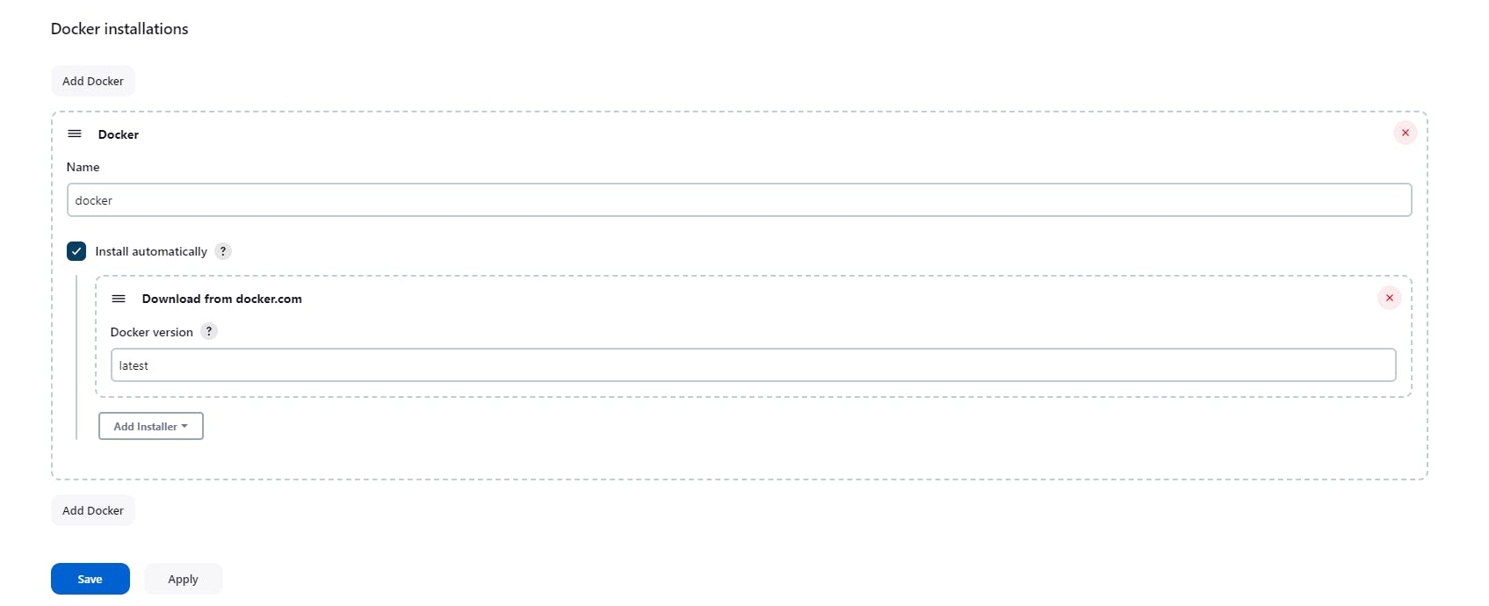
Add this stage to Pipeline Script
COPY
COPY
stage("Docker Build & Push"){
steps{
script{
withDockerRegistry(credentialsId: 'docker', toolName: 'docker'){
sh "docker build -t swiggy ."
sh "docker tag swiggy surajpjoshi/swiggy:latest "
sh "docker push surajpjoshi/swiggy:latest "
}
}
}
}
stage("TRIVY"){
steps{
sh "trivy image surajpjoshi/swiggy:latest > trivyimage.txt"
}
}

Stage View -
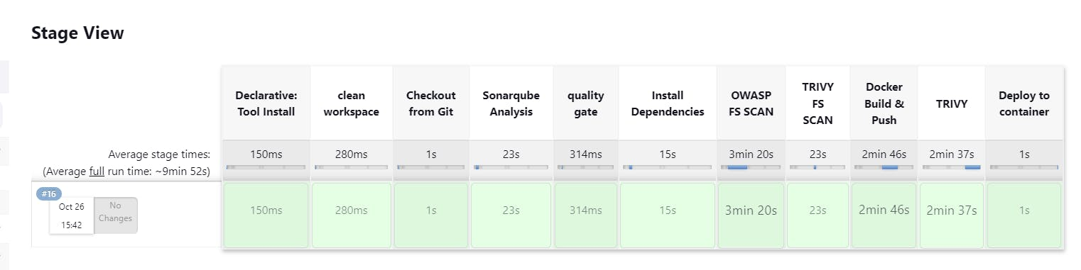
log in to Dockerhub, you will see a new image is created
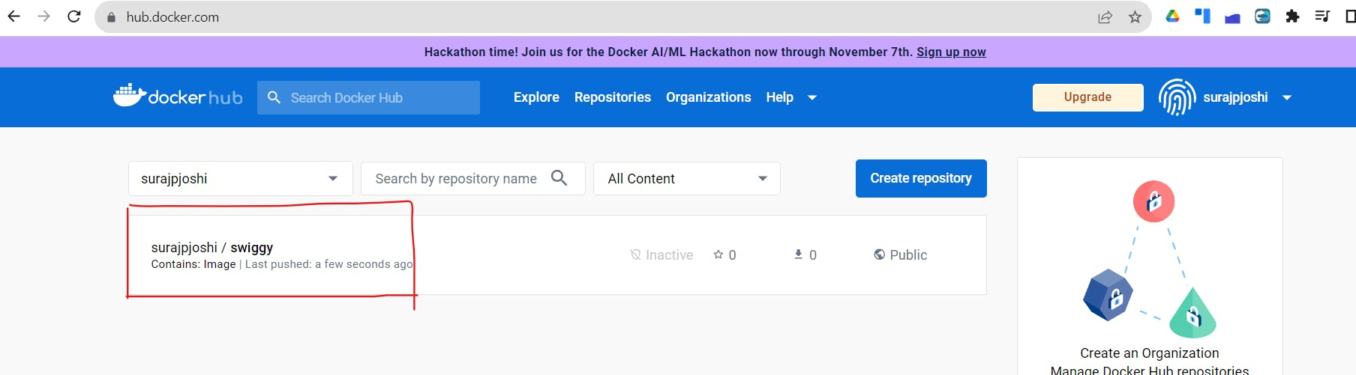
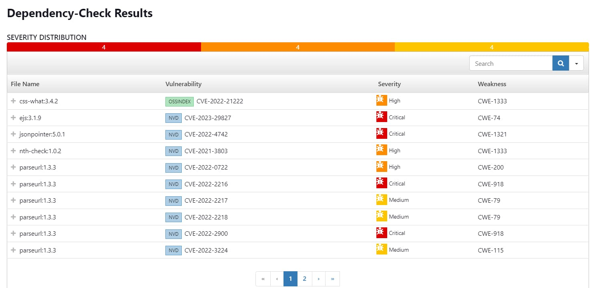
http://13.127.165.163:3000


Let's set Infra for Kubernetes using Terraform to deploy the Swiggy app :
1. Kubectl is to be installed on Jenkins also
COPY
COPY
sudo apt update
sudo apt install curl
curl -LO https://dl.k8s.io/release/$(curl -L -s https://dl.k8s.io/release/stable.txt)/bin/linux/amd64/kubectl
sudo install -o root -g root -m 0755 kubectl /usr/local/bin/kubectl
kubectl version --client

2. Using the below GitHub repo configure Kubernetes
https://github.com/surajpjoshi/Kubernetes-Installation.git
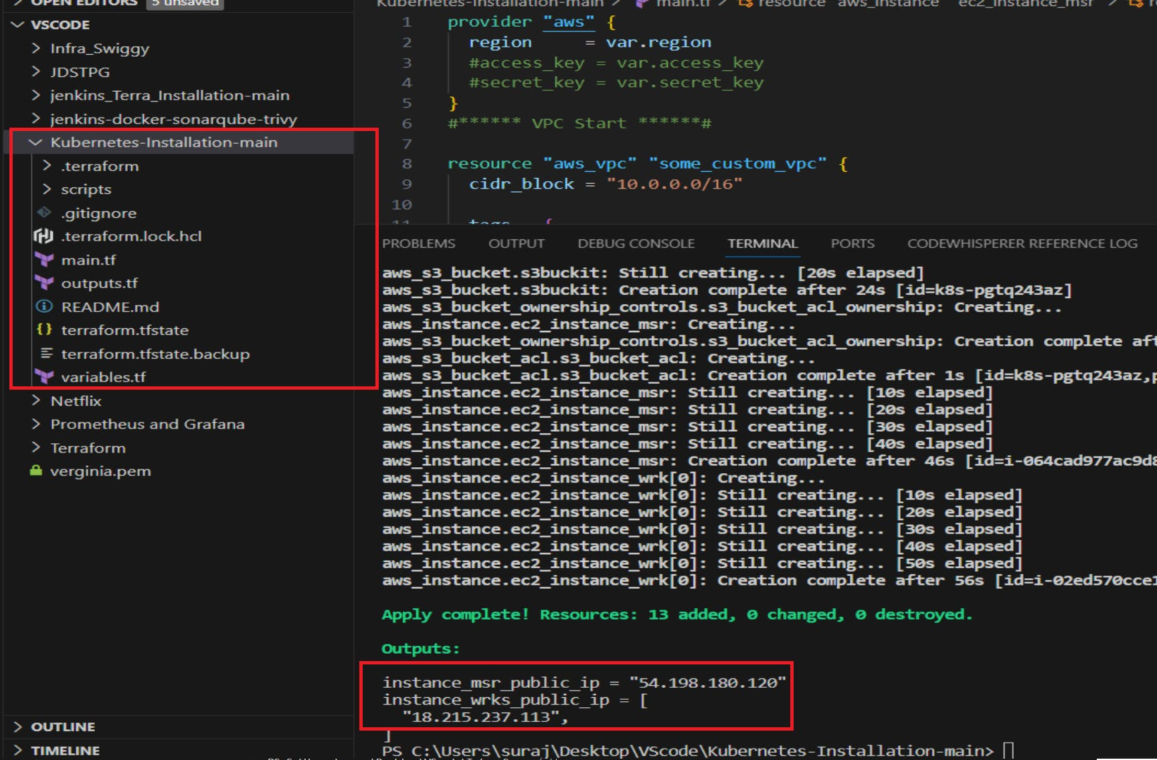
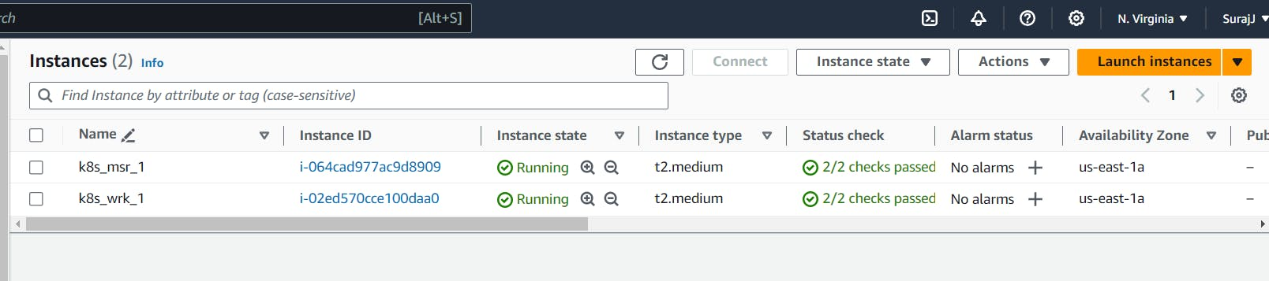
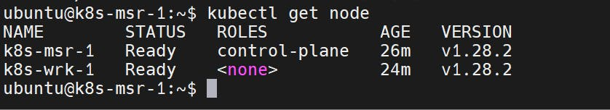
Go to Master & type the below commands to get the certificate configuration
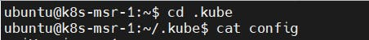
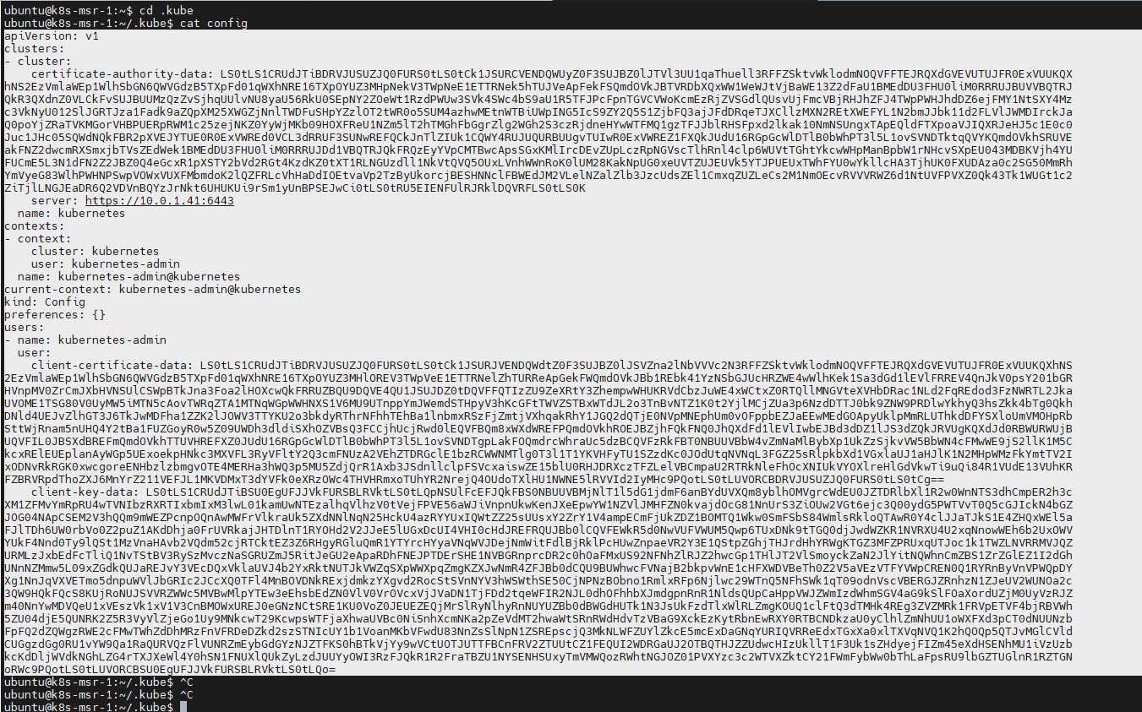
copy it and save it in documents or another folder save it as secret-file.txt
Note: create a secret-file.txt in your file explorer save the config in it and use this at the kubernetes credential section.
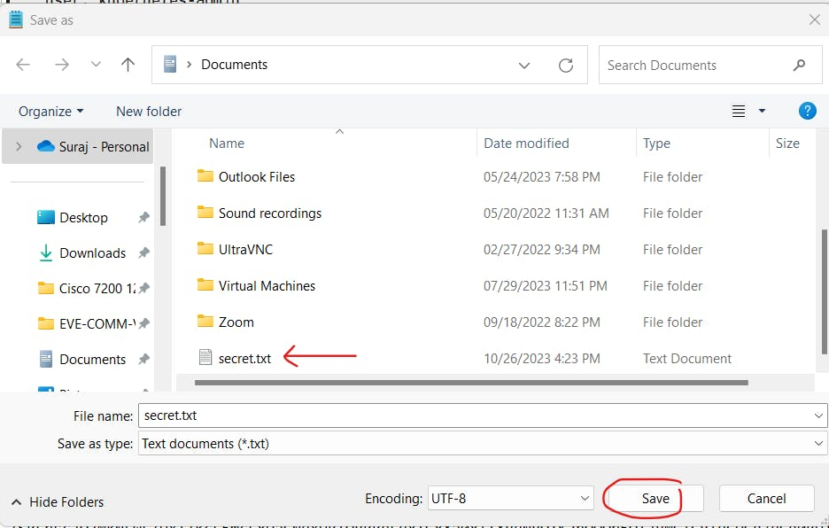

Add the below plugins for Kubernetes
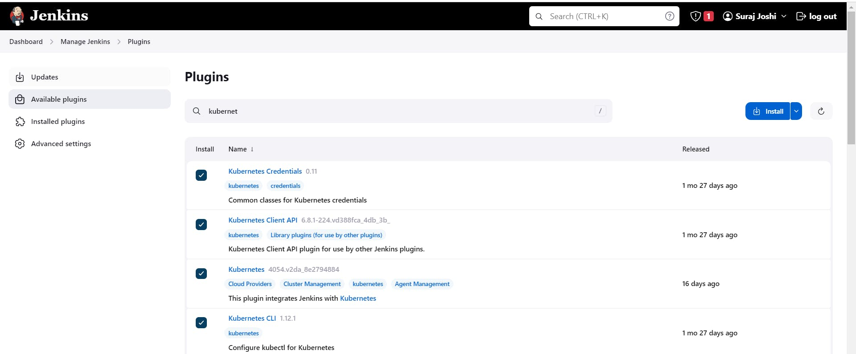

goto manage Jenkins --> manage credentials --> Click on Jenkins global --> add credential
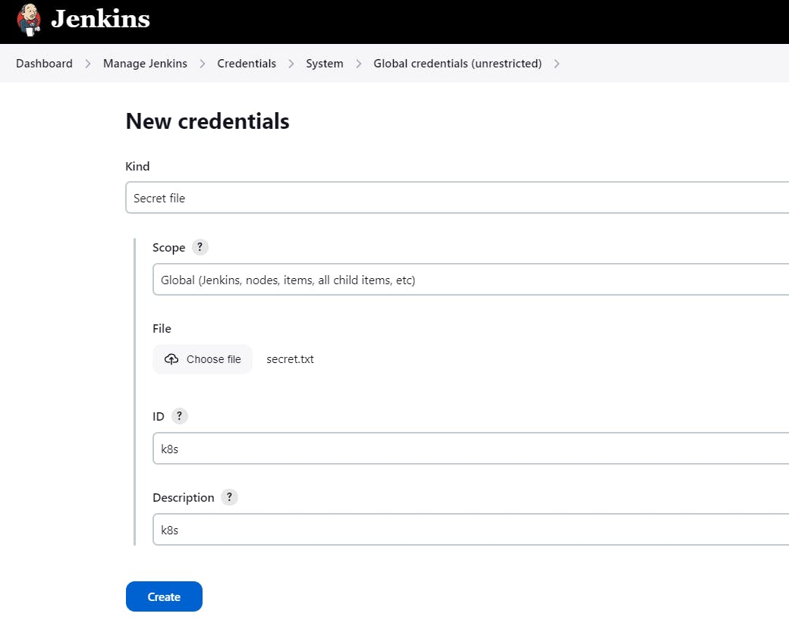
Add Below stage to our pipeline
COPY
COPY
stage('Deploy to kubernets'){
steps{
script{
dir('Kubernetes') {
withKubeConfig(caCertificate: '', clusterName: '', contextName: '', credentialsId: 'k8s', namespace: '', restrictKubeConfigAccess: false, serverUrl: '') {
sh 'kubectl apply -f deployment.yml'
sh 'kubectl apply -f service.yml'
}
}
}
}
}
Build Now:
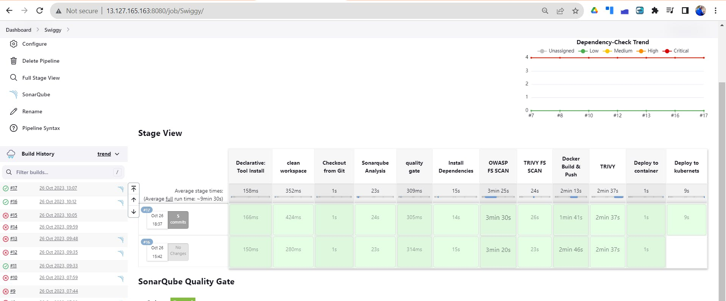

Final output after deployment to Kubernetes
http://18.215.237.113:30007


